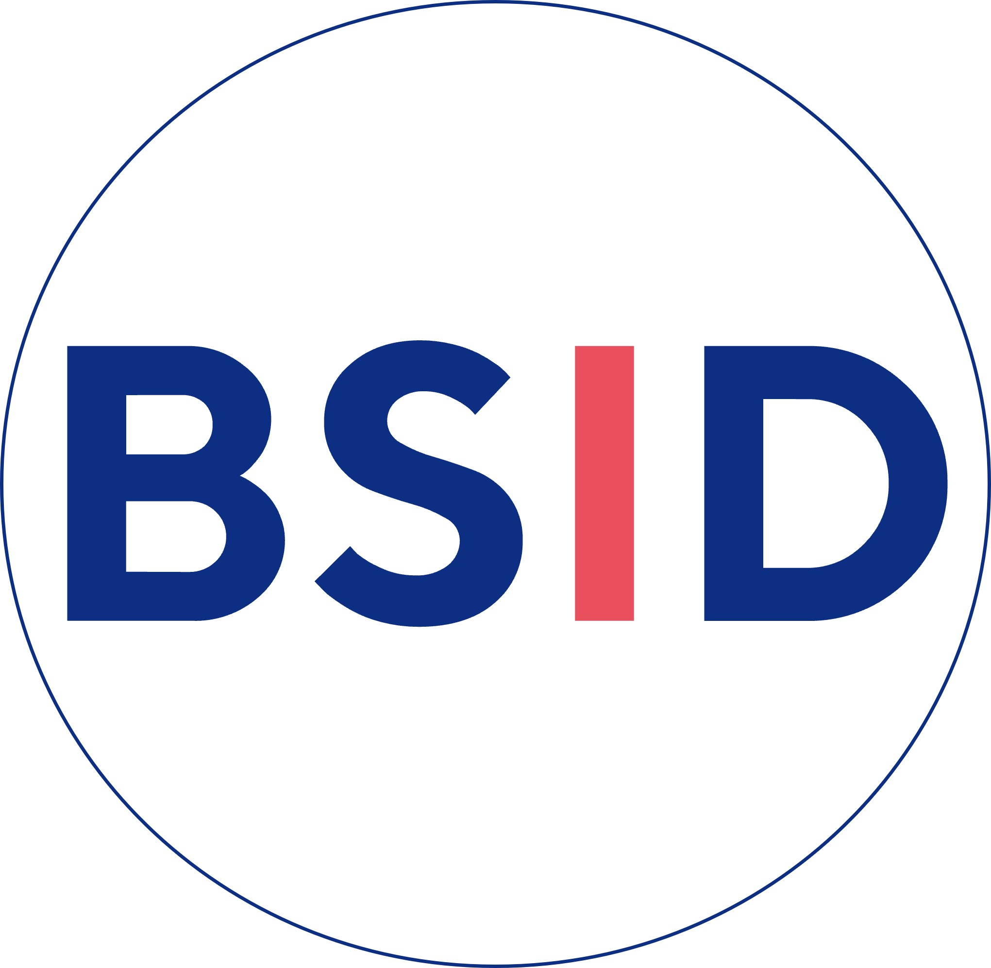
British Society for Investigative Dermatology (BSID)
Early Career Award Application Form

The BSID Early Career Award is for early career investigators who are ratified* BSID members and have made a significant contribution to the BSID and to UK dermatological research. Early career investigators must have completed a PhD or equivalent higher research degree, and not established as independent researcher (with a faculty position). If you are uncertain about whether you are eligible, please contact ukbsid@gmail.com.

Please return the completed application form and a letter of support from your Head of Department to conference@bad.org.uk by 11.59 pm on Monday 15th December 2025
Please ensure you title your email “Early Career Award Application – BSID 2026”

Name:

When did you become a ratified* member of BSID? DD / MM / YYYY

Category: Clinician scientist

Basic/translational scientist
Education

Institution | Degree | Dates

Posts held

Post | Start date | End date

Email address:

In 500 words or less – please outline your research achievements and research impact to date and why you are deserving of an Early Career Research award:

Word count: 500
In 500 words of less – please detail how you have contributed to the BSID:

Word count: 500
Please list your 5 most significant publications (including title, author list, PMID) and, in 100 words or less, the significance and/or impact of each publication:

Publication 1:

Evidence of significance/impact for publication 1 (100 words or less):

Publication 2:

Evidence of significance/impact for publication 2 (100 words or less):

Publication 3:

Evidence of significance/impact for publication 3 (100 words or less):

Publication 4:

Evidence of significance/ impact for publication 4 (100 words or less):

Publication 5:

Evidence of significance/impact for publication 5 (100 words or less):

Please list your current/previous awards/prizes/research grants:

Title of award/prize/ research grant | Awarding body | Date | Role on research grant (PI, Co-I), if applicable | Value of research grant, if applicable

Please return the completed application form and a letter of support from your Head of Department to conference@bad.org.uk by 11.59 pm on Monday 15th December 2025
Please ensure you title your email “Early Career Award Application – BSID 2026”

*Ratification of BSID members occurs at the BSID Annual General Meeting

