The "bottom-up fabrication" of DNA origami is an approach developed by Rothemund in 2006 for the fabrication of highly complex nanostructures by self-assembly, which allows the creation of 2D and 3D objects of arbitrary shape. DNA origami nanostructures are particularly well suited as substrates for the assembly of various functionalities such as proteins, nanoparticles, or specific DNA structures with unprecedented precision that can be assessed by numerous spectroscopic and microscopic techniques. In particular, the immobilization of individual proteins on DNA origamis appears attractive for the observation of conformational changes and folding by single-molecule techniques. Chemical denaturants such as urea and guanidinium chloride are commonly used to trigger such transitions in proteins. The effects of these chaotropic salts are well described for proteins, less so for DNA, and hardly at all for DNA origami nanostructures. Moreover, because of the unique properties of DNA nanostructures, their interaction with denaturants is of fundamental interest.
To reveal the interplay between DNA origami and chaotropic agents, atomic force microscopy (AFM) images of the denaturation process of DNA origami triangles with different guanidinium salts were compared with the corresponding circular dichroism spectra. The AFM data show an early break of the origami, while the hyperchromic shift indicates that the original melting process starts much later. Using principal component analysis, iterative target test factor analysis (ITTFA) and various methods of 2D correlation spectroscopy, the two processes can be correlated and explained with a thermodynamic model by the additional factor of a change in heat capacity. It is found that DNA-origami nanostructures undergo changes in secondary structure leading to breaks at the vertices. The reason for this could be due to the specific interaction of counter anions that shape the properties of the surrounding water structure and thus control the interaction between DNA and guadinium. These findings help to optimally tailor DNA-origami as a substrate for denaturant-induced folding dynamics of individual proteins while improving the fundamental understanding of the effects of water structure on DNA.

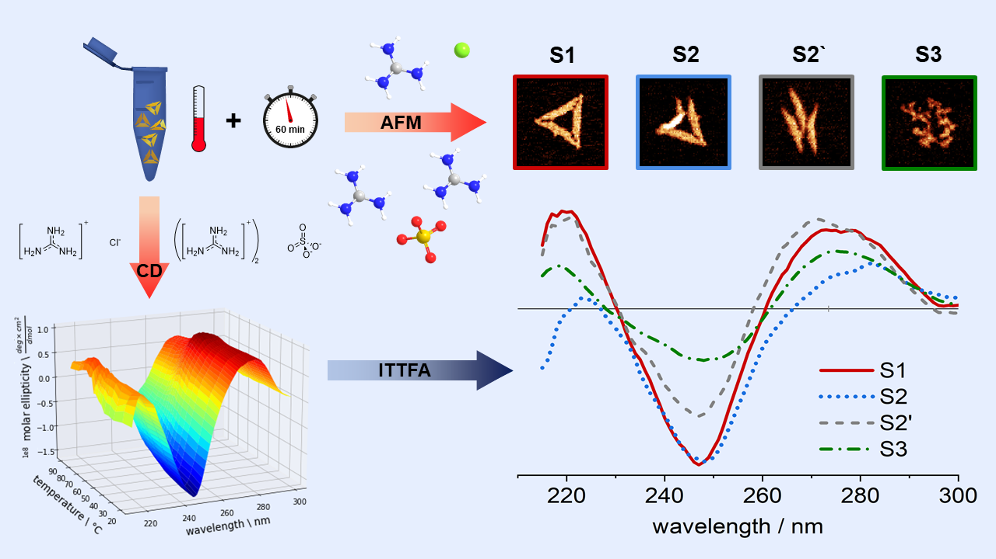
Figure 1. Experimental approach: The nanostructural integrity of DNA origami triangles after exposure to GdmCl and Gdm2SO4 for one hour is evaluated at selected temperatures by atomic force microscopy (AFM). Temperature-dependent DNA melting in the DNA origami triangles is assessed under equivalent conditions by circular dichroism (CD) spectroscopy. An iterative target test factor analysis (ITTFA) of the CD spectra primed with the fractions of intact and damaged DNA origami observed in AFM allows us to identify four different structural states (S1 – S4) occurring during DNA origami melting and their individual coun-teranion-independent component spectra.

