Cation-Responsive and Photocleavable Hydrogels from Noncanonical Amphiphilic DNA Nanostructures
Giacomo Fabrini¹ (email: g.fabrini19@imperial.ac.uk), Aisling Minard¹, Ryan A. Brady², Marco Di Antonio¹, and Lorenzo Di Michele^{1, 3}
¹ Imperial College London, United Kingdom; ² King’s College London, United Kingdom;
³ University of Cambridge, United Kingdom
Thanks to its biocompatibility, versatility and programmable interactions, DNA has become increasingly popular as a building block for 2D and 3D nanoarchitectures and nanomaterials. Given the exploding interest in synthetic biology and nanomedicine, growing attention has been devoted to functional, stimuli-responsive DNA frameworks for applications in artificial cells, biosensing, tissue engineering and drug delivery, particularly in the form of DNA-based hydrogels [1, 2, 3]. However, the applicability of such nanomaterials in vivo is still hampered by the inability of most DNA nanostructures to reversibly respond to physiological stimuli, such as cation concentration or pH. So far, indeed, most implementations rely on strand displacement, which use non biologically available, single-stranded DNA as input.
Here, we present how combining cation-responsive DNA G-quadruplex (G4) structures with amphiphilic DNA constructs [4, 5] produces noncanonical nanostructures, which we termed "Quad-Stars" [6], capable of assembling isothermally into responsive hydrogel aggregates via a simple, enzyme-free, one-pot reaction. The embedded G4 structures allow us to reversibly trigger and kinetically control the assembly/disassembly by adding or removing K⁺ ions. The hydrogel particles can further be photo-disassembled in a localised and irreversible way upon near-UV irradiation in the presence of a G4-binding porphyrin photosensitiser. The combined reversibility of assembly, cation-responsiveness, cargo-loading capabilities and biostability under model physiological conditions make Quad-Stars an excellent candidate for next-generation biosensors and responsive drug delivery carriers.
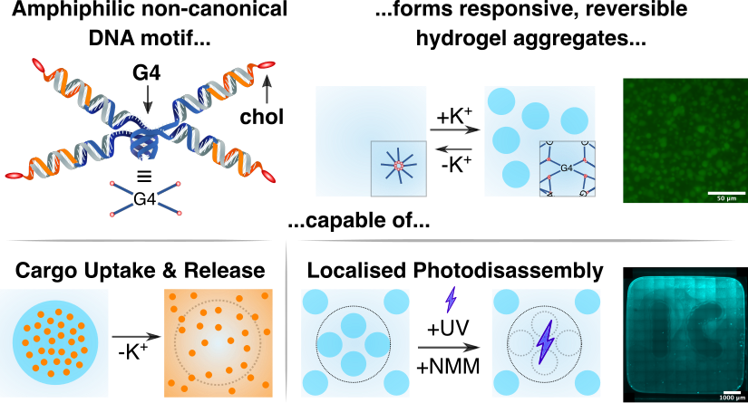
Fig. 1. Quad-Stars self-assemble in the presence of K⁺ ions and disassemble upon their chelation thanks to the tetramolecular G4 structure joining the four double-stranded arms together. Thanks to the cholesterol moieties, the hydrogel aggregates can uptake small hydrophobic molecules and release them upon disassembly. Near-UV exposure in the presence of a porphyrin photosensitiser further leads to guanine photo-oxidation and localised, irreversible disassembly of the aggregates.
[1] D. Wang et al., Acc. Chem. Res. 2017, 50, 4, 733–7392.
[2] N. Yewdall et al., Curr. Opin. Colloid Interface Sci. 2021, 52, 101416.
[3] R. Rubio-Sánchez, G. Fabrini et al., Chem. Commun. 2021, 57, 12725.
[4] R. A. Brady et al., Nano Lett. 2017, 17, 5, 3276–3281.
[5] R. A. Brady et al., J. Am. Chem. Soc. 2018, 140, 45, 15384–15392.
[6] G. Fabrini et al., Nano Lett. 2022, 22, 2, 602–611.

